Saint Louis University

School of Accountancy Management and Computing Information Studies

Programming Application (S.Y. 2018 - 2019)

**INSTALLATION and USER MANUAL**

9455B 4:00 - 5:30 MTH

Submitted by:

3 ABUIZA, Okimwa N.

5 AGUILAR, Allen Zyra Neil A.

13 DOMINGCIL, Jay Tyrone L.

14 DUCUSIN, Chester John E.

19 LOPEZ, Floidrex C.

25 PANOPIO, Russel Jacob L.

30 RAGSAC, John-Yves B.

32 SOBREMONTE, Adam Andrei N.

40 FERNANDO, Kimberlyn C.

41 GADDI, Julina May J.

Submitted to:

Mr. Roderick Makil

*Superviser*

Date Submitted:

November 2018

TABLE OF CONTENTS

INSTALLATION MANUAL

Git

SVN

USER MANUAL

Git

SVN

**INSTALLATION MANUAL**

1. **Configuration of the ORACLE Virtual Machine (VM) - Ubuntu Server**

Source: <https://www.virtualbox.org/wiki/Downloads>

1. **Tools used:** 
   1. Ubuntu Server 18.04.1 LTS (iso)

Source: <https://www.ubuntu.com/download/server>

* 1. Oracle VM VirtualBox
  2. 64Bit Operating System

**PROCEDURES:**

*Step 1:* Download Oracle Virtual Machine (VM) version 5.2.16 first in your desktop then install. Source: <https://www.virtualbox.org/>

*Step 2:* Name your server as UbuntuServer, use Linux as the Type and Ubuntu (64-bit) for your version. Then click **Next**.

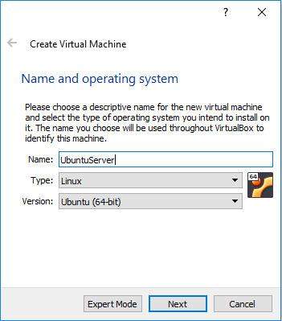

*Figure 1. Name and operating system*

*Step 3*: Select 1024 MB for your Memory Size. Then click **Next.**

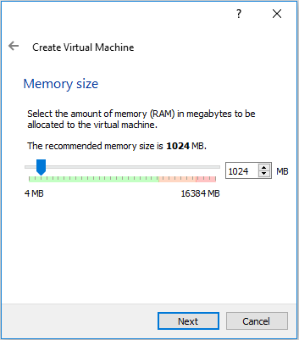

*Figure 2. Memory Size*

*Step 4*: Choose Create a virtual hard disk now for your Hard Disk, then click **Create.**

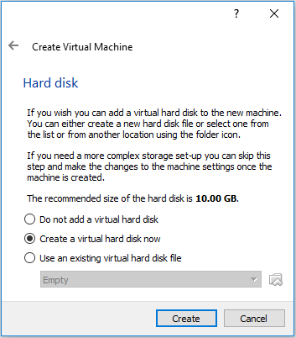

*Figure 3. Hard Disk*

*Step 5*: Choose VDI(VirtualBox Disk Image) for your Hard disk file type, then click **Next.**

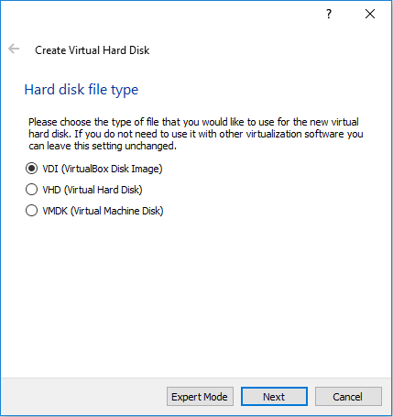  
*Figure 4. Hard Disk File Type*

*Step 6:* Type **UbuntuServer** and click the folder icon to select a location. Then click **Create**.

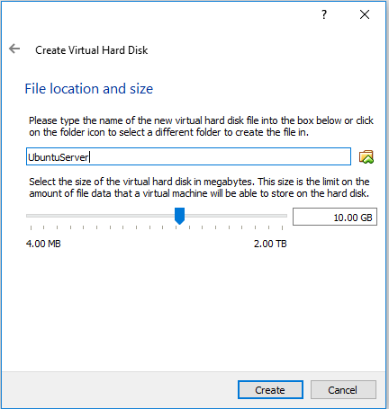

*Figure 5. File Location and Size*

*Step 7:* The ***UbuntuServer*** is successfully created.

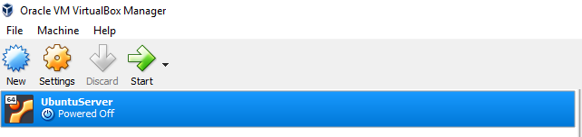

*Figure 6. Successfully created ubuntu server*

*Step 8:* Go to System and select 1024 mb for the base memory. Check Optical and Hard Disk for Boot Order, PIX3 for Chipset, USB Tablet for Pointing Device and check Enable I/O APIC and Hardware Clock in UTC Time. Then click **Ok.**

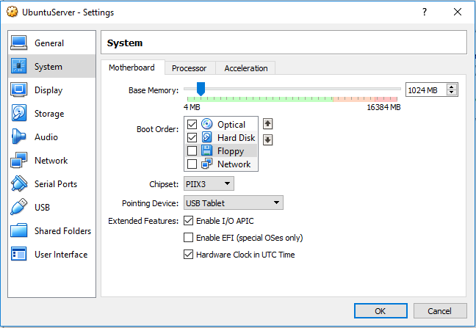

*Figure 7. Configuring the system*

*Step 9*: Browse for the Ubuntu iso file then click **Open.**

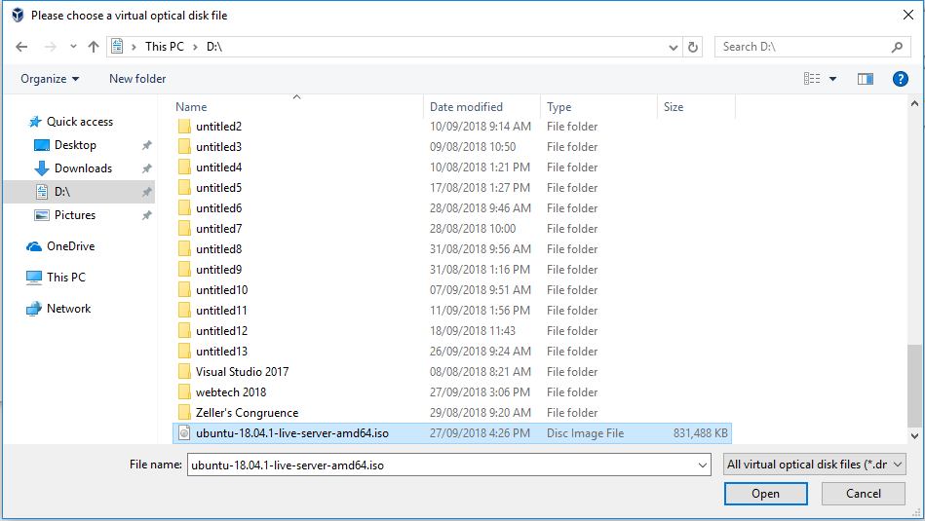

*Figure 8. Location of the iso file*

*Step 10:* For the attributes, select IDE Primary Master then click **OK.**

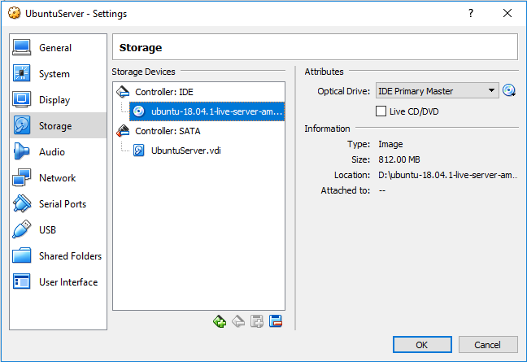

*Figure 9. Configuring the storage*

*Step 11:* Select Bridged Adapter for Attaching and Realtek PCIe GBE Family Controller For the Name then click **OK.**

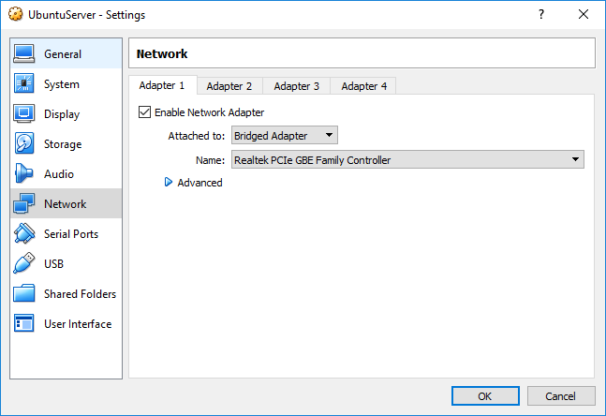

*Figure 10. Configuring the Network*

*Step 12:* Select your language then click **Enter.**

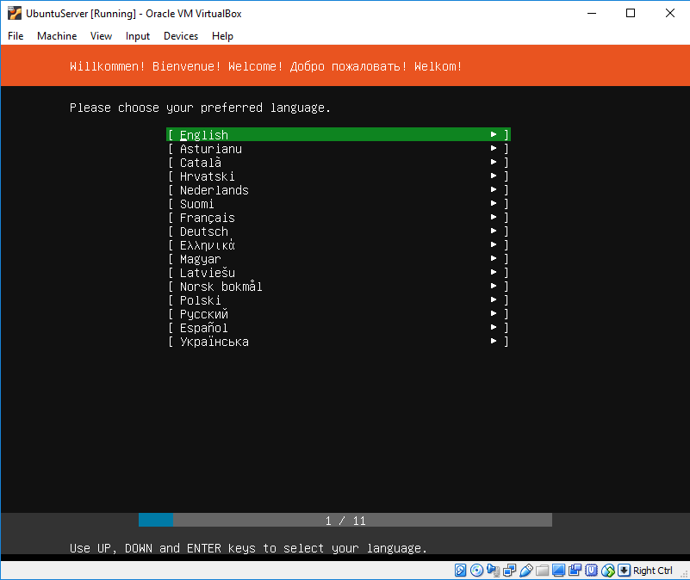

*Figure 11. Choosing the preferred language*

*Step 13:* Use UP and DOWN Keys to Select and Click **Enter.**

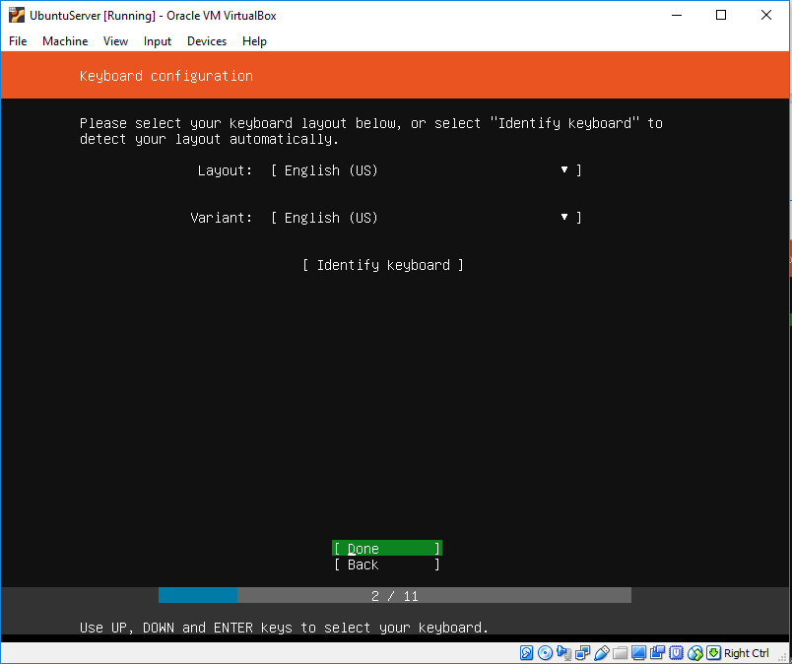

*Figure 12. Keyboard Configuration*

*Step 14:* Choose *Install Ubuntu* then **Enter.**

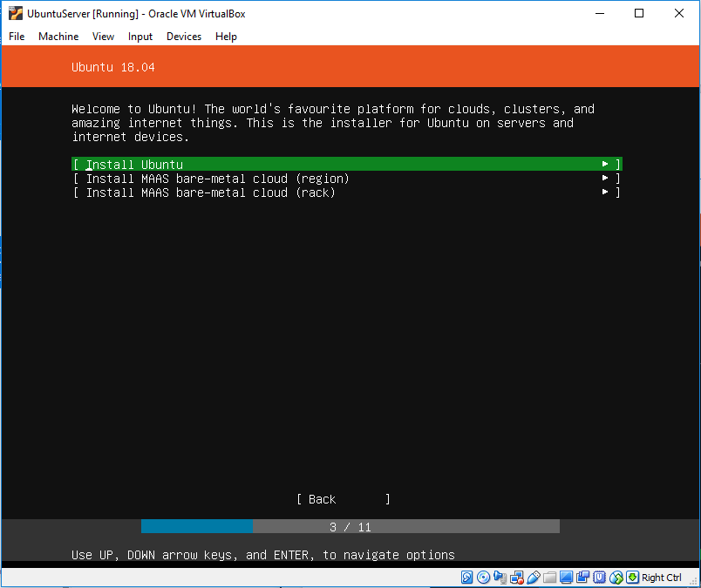

*Figure 13. Installing ubuntu*

*Step 15:* Select an Interface to configure or select **Done** to continue.

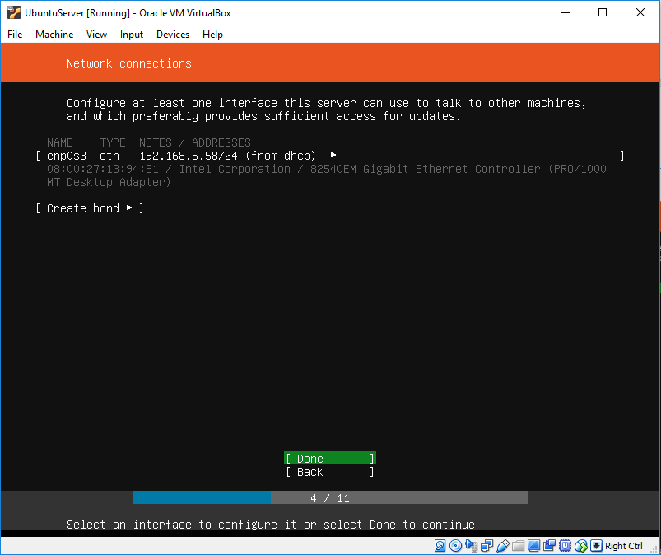

*Figure 14. Network connections*

Step 16: Select **DONE.**

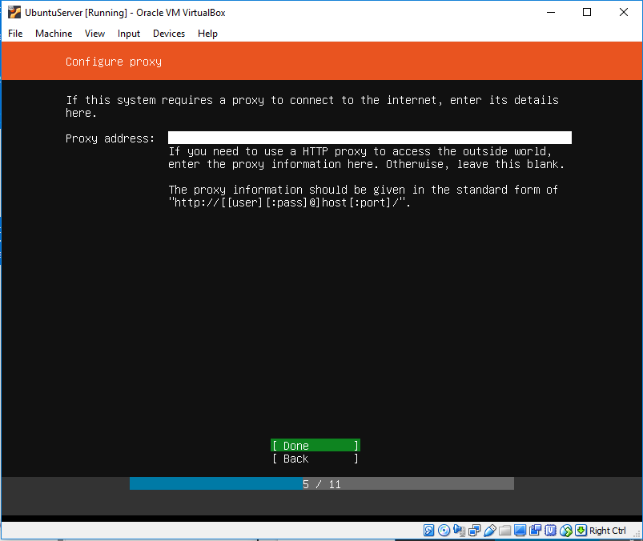

*Figure 15. Configure proxy*

Step 17: Copy and paste the address of the *archive.ubuntu*

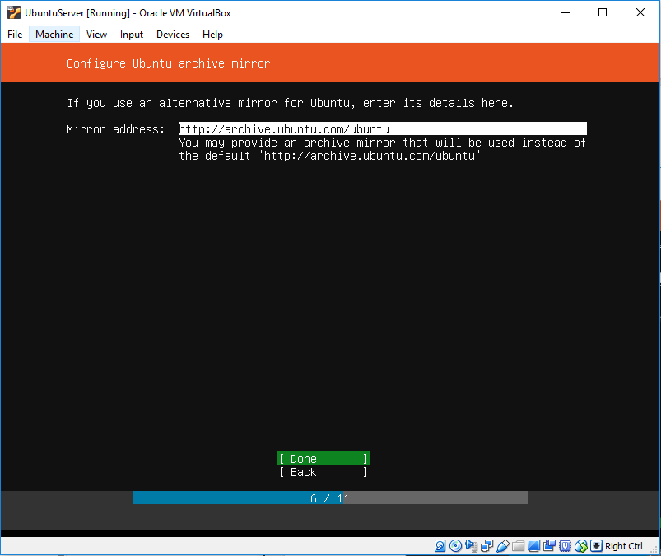

*Figure 16. Configure Ubuntu archive mirror*

*Step 18:* Select a manual or guided partitioning and then select ***Use an Entire Disk.***

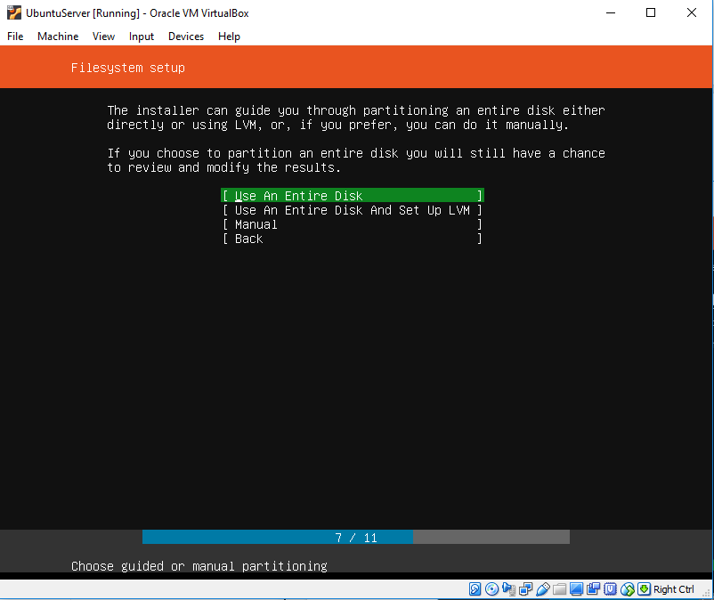

*Figure 17a. Filesystem setup*

*Step 19:* Choose ***VBOX_HARDDISK***

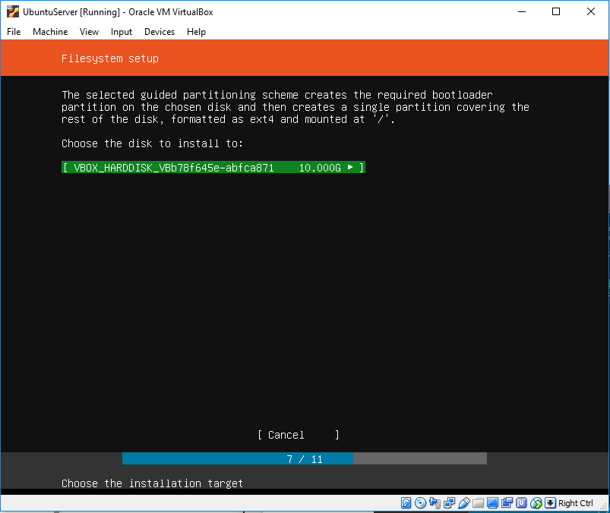

*Figure 17b. Filesystem setup*

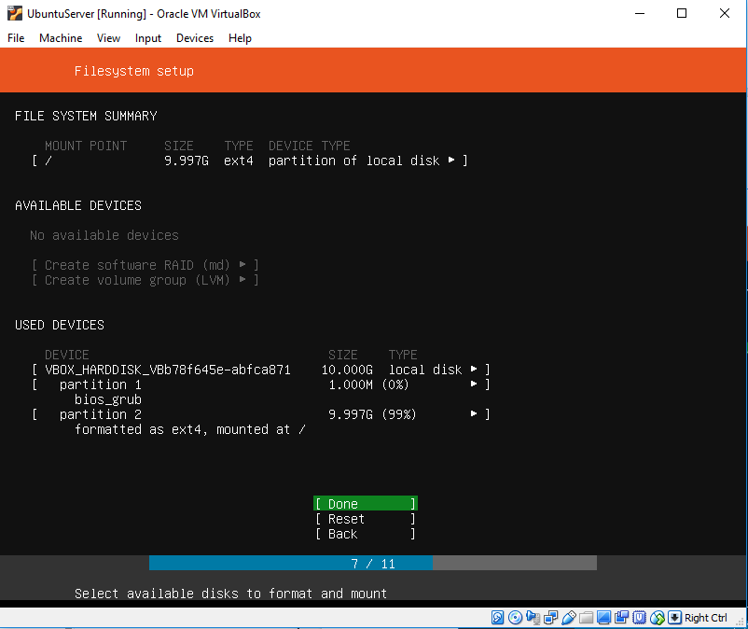

*Figure 17c. Filesystem setup*

*Step 20:* Choose ***Continue.***

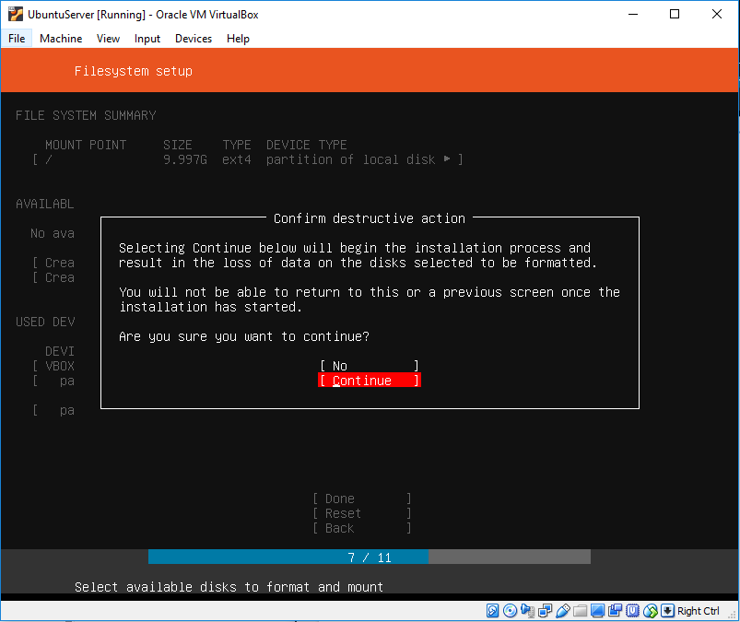

*Figure 17d. Filesystem Setup*

*Step 21:* Fill in the Profile Setup and enter ***Done.***

Username: ubuntuserver

Password: ubuntuserver

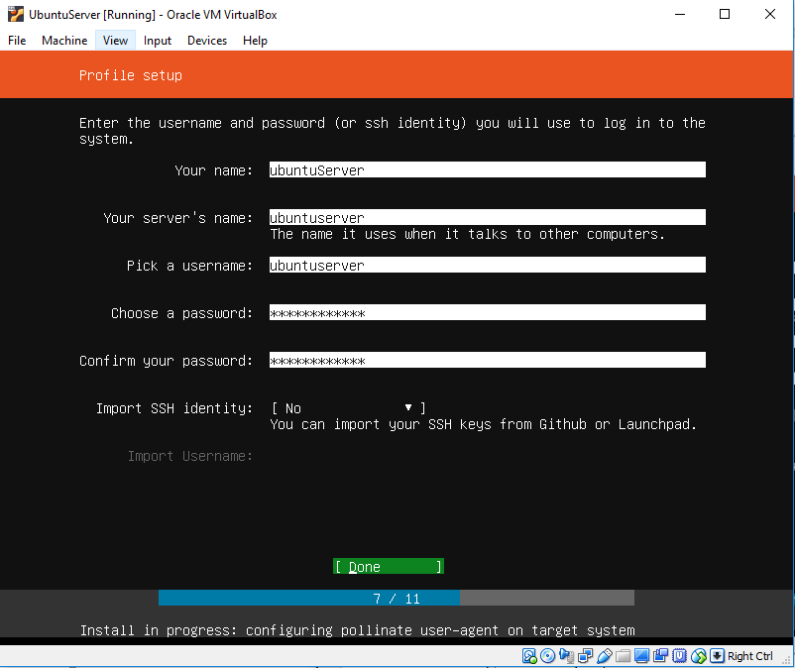

*Figure 18. Profile setup*

*Step 22:* Select ***Done*** and then ***Enter***.

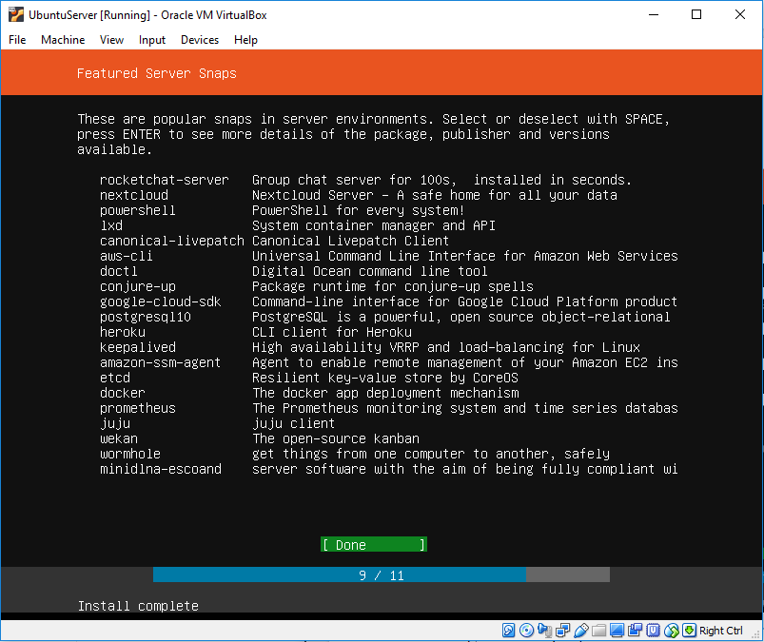

*Figure 19. Featured Server Snaps*

Step 23: Select ***Reboot Now*** then click ***Enter***.

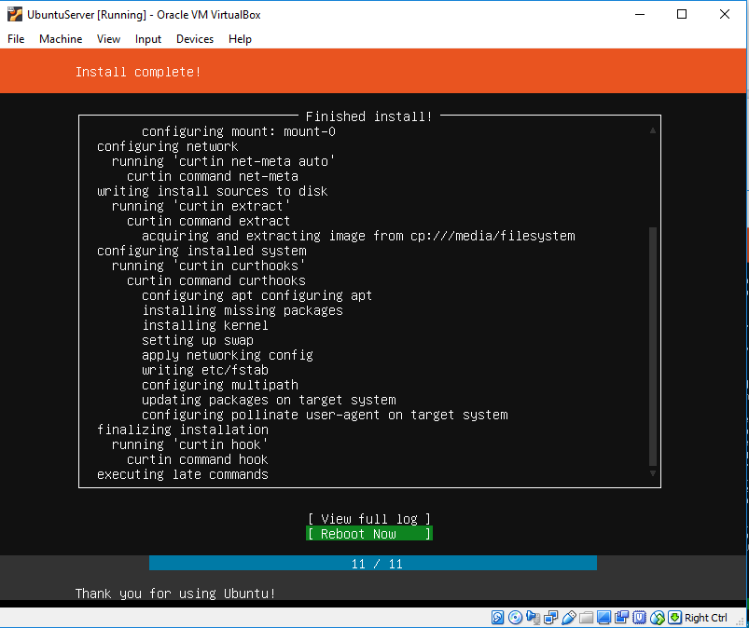

*Figure 20. Installation complete*

**INSTALLATION MANUAL (GIT)**

1. **Git installation**

* Installing Git Bash on Windows

1. **Tools Used**

*Step 1*: To download Git on window, download the Git Bash installer from <https://git-scm.com/downloads> then choose the Operating System of your computer.



*Figure 1. Git Bash Download site*

*Step 2:* Then run the Git installer then follow the default configuration set up by clicking **Next**

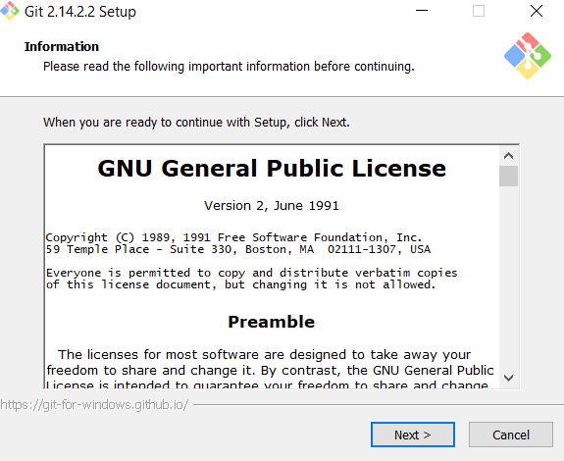

*Figure 2. Git Bash Terms and Conditions*

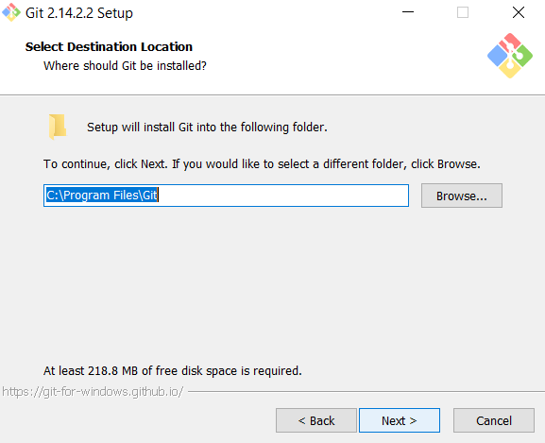

*Figure 3. Specifying Directory*

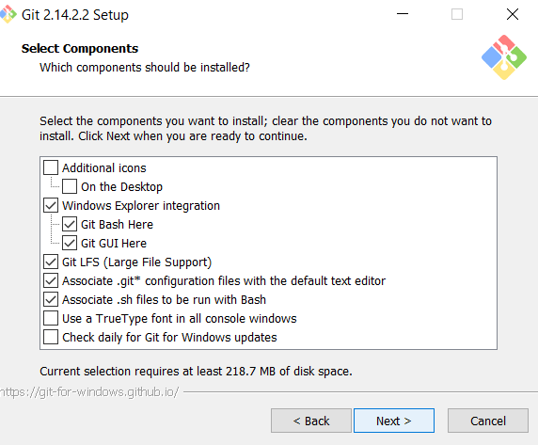

*Figure 4. Selecting components*

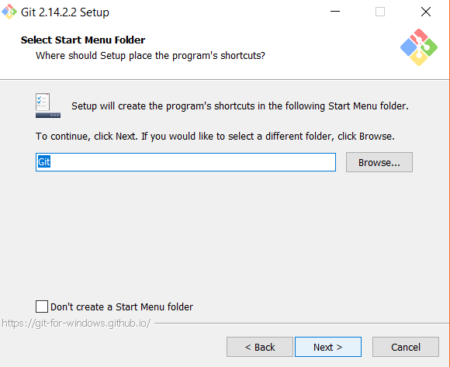

*Figure 5. Selecting Start Menu Folder*

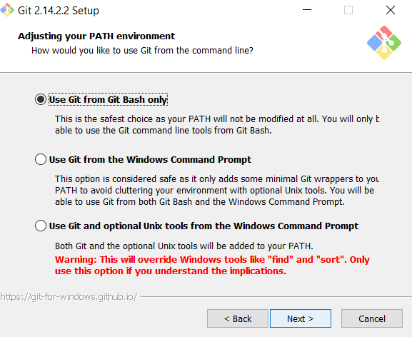

*Figure 6. Setting PATH environment*

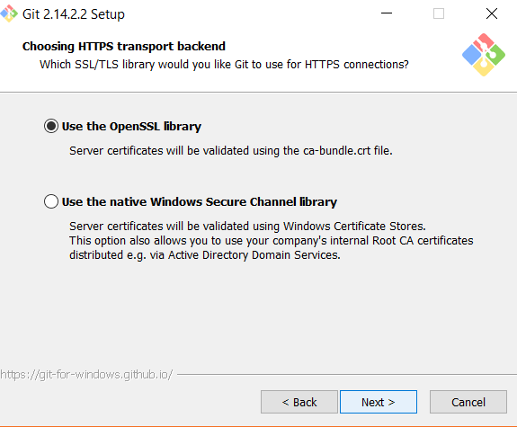

*Figure 7. Choosing HTTPS transport Background*

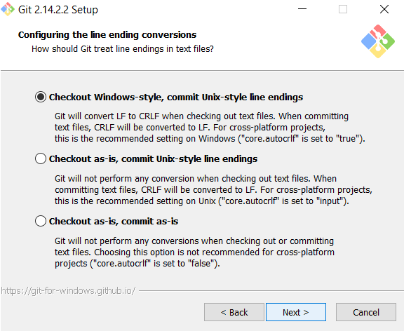

*Figure 8. Configuring Ending conversions*

*Step 3*: Then configure the extra option you want to install then click **install.**

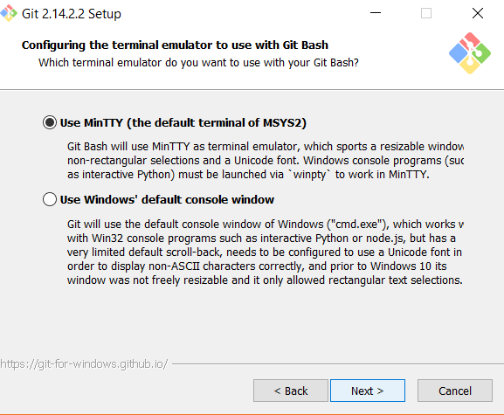

*Figure 9. Configuring Terminal Emulator*

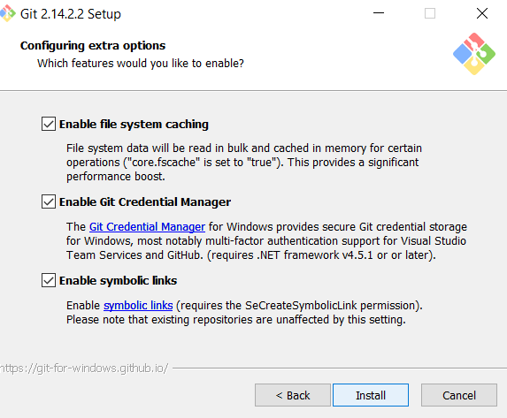

*Figure 10. Configuring Extra Options*

*Step 4:* Then, click **Finish** to finish installing Git Bash

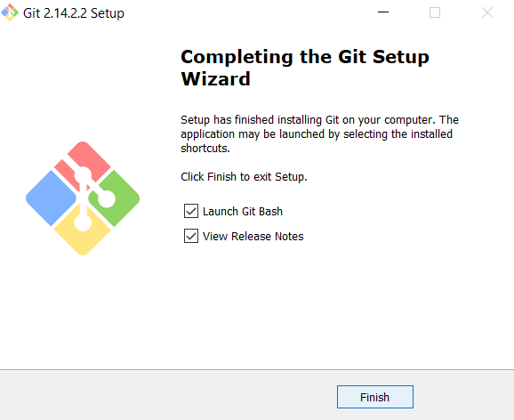

*Figure 11. Completing Git Bash Setup*

*Step 5:* Then to run your Git Bash, **Right Click your mouse - Git Bash Here**

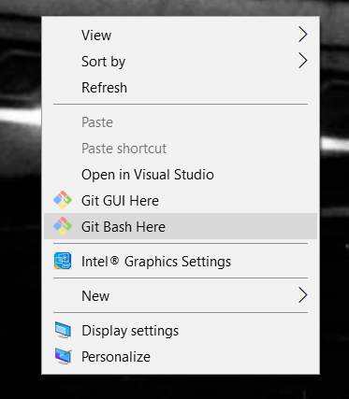

*Figure 12. Opening Git Bash from Desktop*

**USER MANUAL (GIT)**

1. **SERVER**

* **Sudo apt-get install git**
* **Setting Up Repository in the server**
  + **Using GIT**

*Step 1:* First, create a folder using the command ***mkdir name***



*Figure 1. Creating Directory for repository*

*Step 2:* Then change your directory so that you are inside the newly

created directory. Enter the command ***cd name***

*Figure 2. Changing Directory*

*Step 3:* Type ***git init -–bare*** to create an empty repository

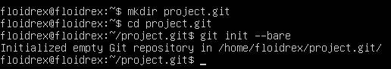

*Figure 3. Creating git repository*

* **Setting Up Accounts and Permissions**
  + Using GIT

*Step 1:* First, create a group for the users by typing ***sudo addgroup groupname***

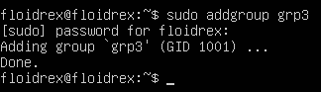

*Figure 1. Creating group for users*

*Step 2:* Then, add a user to the group by typing ***sudo adduser –ingroup groupname username*.** After entering this, you are to enter a password for the user

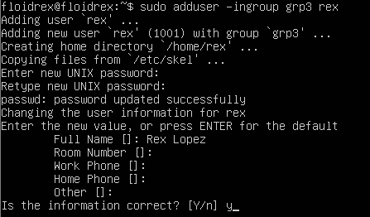

*Figure 2 . Creating User and adding user to group*

*Step 3:* To set permissions, simply type ***sudo* *chgrp –R groupname repositoryName*** to change group ownership type *sudo* *chmod –R g+swX repoName* to set permissions to the repository directory



*Figure 3. Changing group ownership*



*Figure 4. Changing permissions for repository*

**B. Client**

* **Accessing an external repository (Ubuntu Server)**
  + Using GIT

*Step 4:* First, create a folder by typing ***mkdir*** *and the name of the directory.*



*Figure 1 Creating directory*

*Step 5:* Then change directory so that you are inside the newly created directory using ***cd*** *“name of the directory”*



*Figure 2 Creating directory*

*Step 6:* Then, type ***git init*** to create an empty repository



*Figure 3 Creating empty repository*

*Step 7:* Then, type **git remote add origin *hostname@ipaddress:/path/to/repository***



*Figure 4 Adding remote for client*

*Step 8:* Introduce yourself as the user by typing *git config –global user.name ‘name’ and* ***git config –global user.email ‘email’***

**

*Figure 5 Indicating name of user*

**

*Figure 6 Indicating email of user*

* **Push and/or pull a resource from the repository**
  + Using Git

Step 1: To pull a resource from a repository, type **git pull origin master**

Step 2: To push a resource to the repository, type **git push origin master**

* **Update a resource in the repository**
  + Using GIT

Step 1: To update and edited version of the resource to the repository, first add the repository using git add filename

Step 2: Then, commit the added repository by typing **git commit –m ‘commit message’ filename**

Step 3: Then, push the committed resource to the server’s repository

* **Delete a resource in the repository**
  + Using GIT

Step 1: Simply type **git rm –r filename**

Step 2: Then, commit the changes you have made using git commit

Step 3: Then push the committed changes back to the repository

* **View the revisions (history of updates) of a resource**
  + Using GIT
  + To view the revisions made to the resource, simply type **git log**
* **Revert to a previous version of an existing resource in the repository**
  + Using GIT

1. **Reverting uncommitted changes**

Simply type **git checkout --filename**

**INSTALLATION MANUAL (SVN)**

Reference: <https://help.ubuntu.com/lts/serverguide/subversion.html.en>

<https://openoffice.apache.org/svn-basics.html>

<https://tecadmin.net/install-subversion-server-on-ubuntu/>

* It is an open source version control system
* Utilizing SVN, you can record the history of source files and documents
* Manages files and directories overtime
* A tree of files is replaced into a central repository

1. **SERVER**

**INSTALLATION OF VISUALSVN SERVER**

VisualSVN Server lets you easily install, control a fully-functional Subversion server for the Windows Platforms. VisualSVN Server is useful, robust and uniquely have an enterprise-grade features. Very useful for both small business to corporate users.

Requirements needed:

### **Operating Systems**

* Windows Server 2008 R2 or later
* Windows 7 or later

### **Minimum hardware**

* 1.4 GHz CPU
* 512 MB RAM
* 50 MB hard drive space

**PROCEDURES:**

*Step 1*: Download and Install VisualSVN Server

***https://www.visualsvn.com/server/download/***

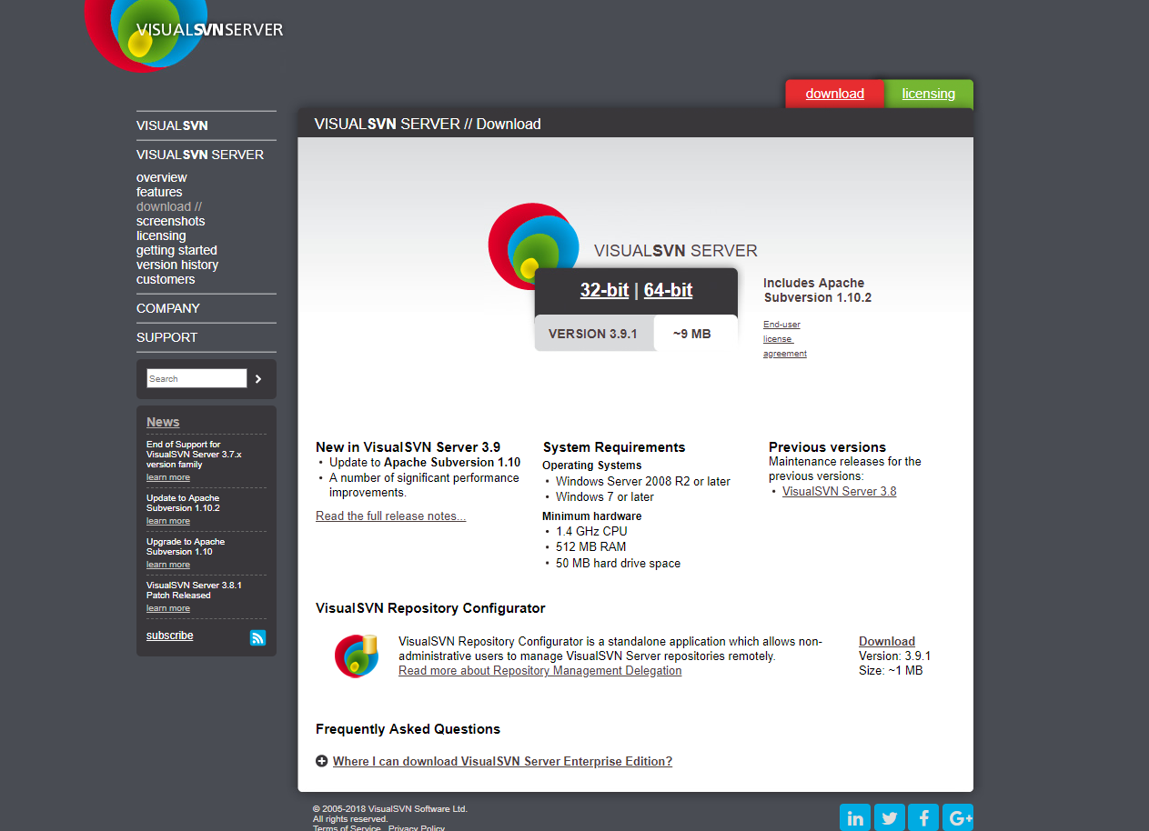

*Figure x. Official website of VisualSVN Server*

*Step 2*: Install the VisualSvn Server and the click **Next**.

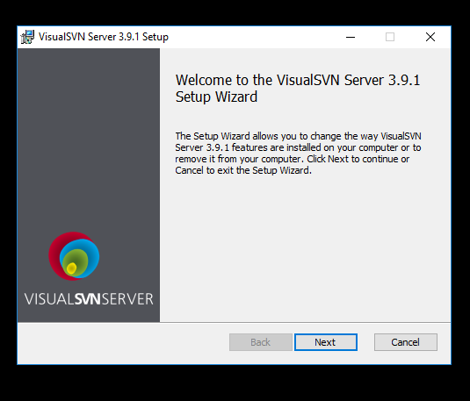

*Figure x. VisualSVN Server Setup*

*Step 3*: Click to agree to the terms in the *License Agreement.* Then click **Next**

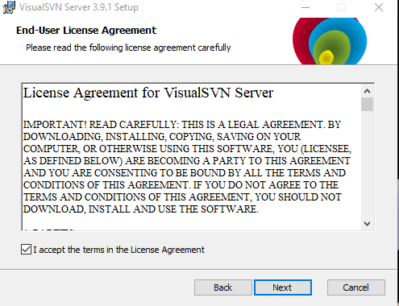

*Figure x. End-User License Agreement for VisualSVN Server*

*Step 4*: Choose **VisualSVN Server and Administration Tools** then click **Next.**

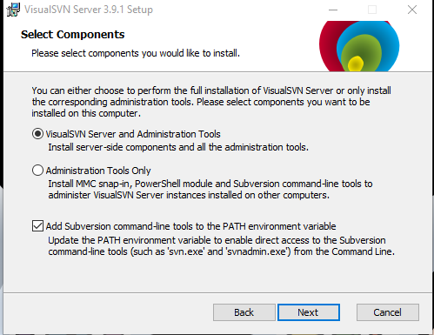

*Figure x. Selecting components*

*Step 5*: Click on the **Standard Edition** button**.**

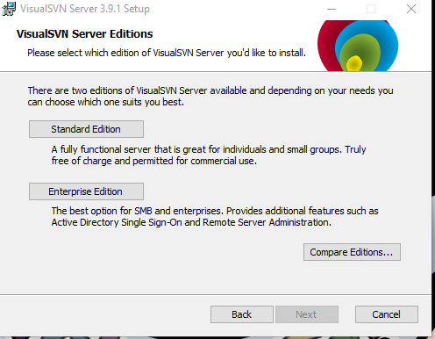

*Figure x. VisualSVN Server Editions*

*Step 6*: Click Next for default configuration or configure the settings if necessary.

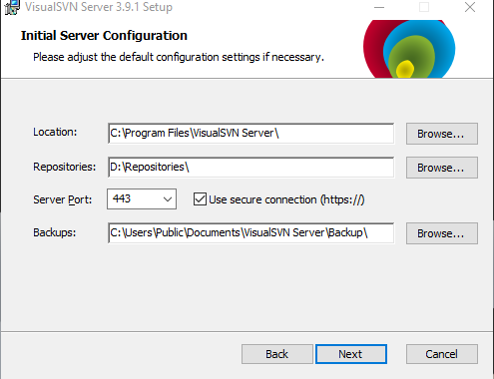

*Figure x. Initial Server Configuration*

*Step 7*: Click **Install**

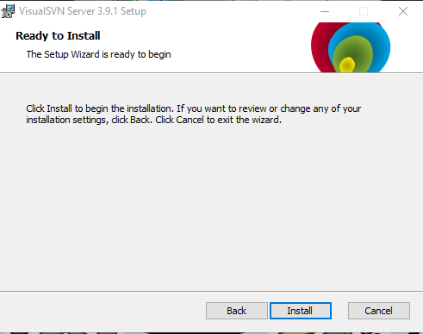

*Figure x. Ready to install*

*Step 8*: You have successfully installed VisualSVN Server.

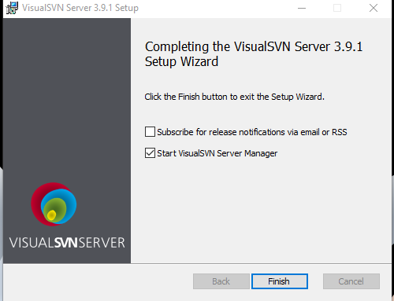

*Figure x. Successfully installed VisualSVN Server*

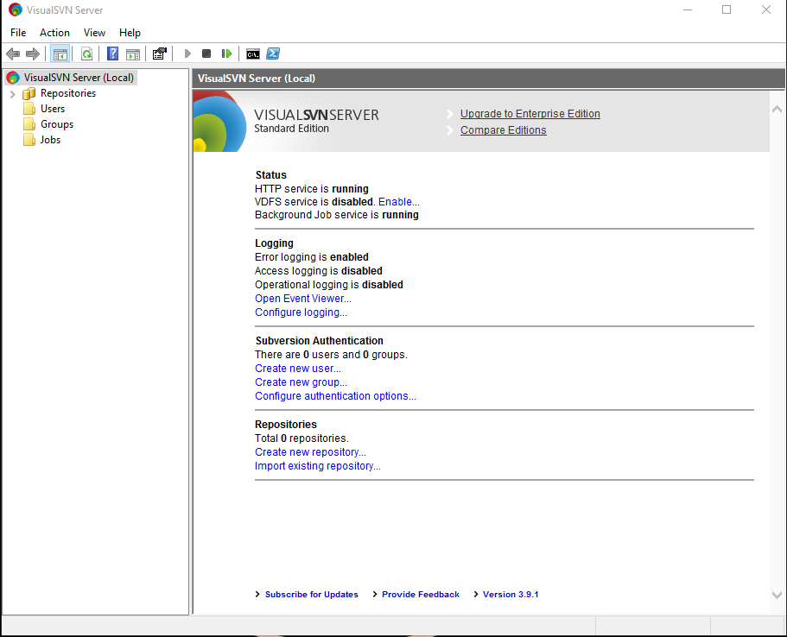

*Figure x. VisualSVN Server program*

**B. CLIENT**

**INSTALLATION OF TORTOISESVN**

TortoiseSVN is an [Apache™ Subversion (SVN)®](http://subversion.apache.org/) client, implemented as a Windows shell extension. It's intuitive and easy to use, since it doesn't require the Subversion command line client to run. And it is free to use, even in a commercial environment. Simply the coolest Interface to Subversion Control.

**Tools needed:**

* TortoiseSVN runs on Windows Vista or higher version
* Available in both 32-bit and 64-bit flavours

**PROCEDURES:**

*Step 1*: Open your browser and go to the website

***https://tortoisesvn.net/downloads.html***

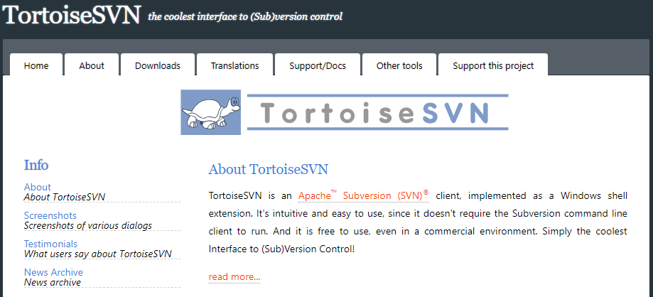

*Figure x. Official Website of TortoiseSVN*

*Step 2*: Go to downloads and install the ***TortoiseSVN 1.9.7 – 64-bit***

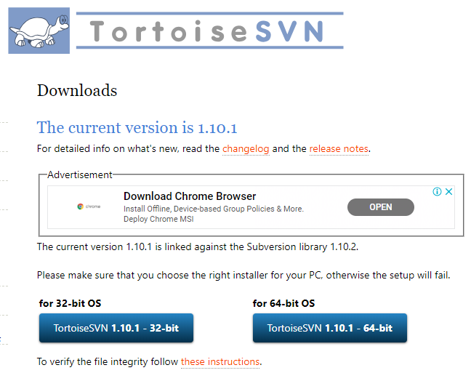

*Figure x. Download section of TortoiseSVN*

*Step 3*: After you have downloaded the file, you can now click on the executable file and then click on the **Run** button.



*Figure x. Executable file of TortoiseSVN*

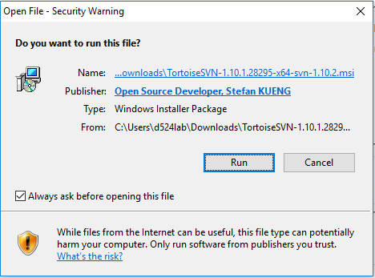

*Figure x. Alert prompt (Run the file)*

*Step 4*: After running the file, just click on the **Next** button and then accept the *End-User License Requirement* by clicking on the **Next** button.

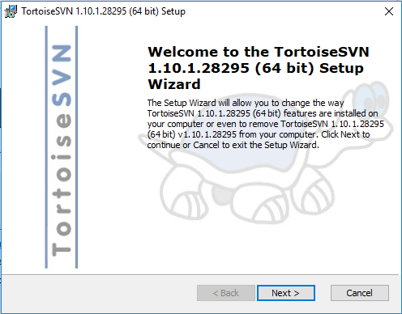

*Figure x. TortoiseSVN Setup*

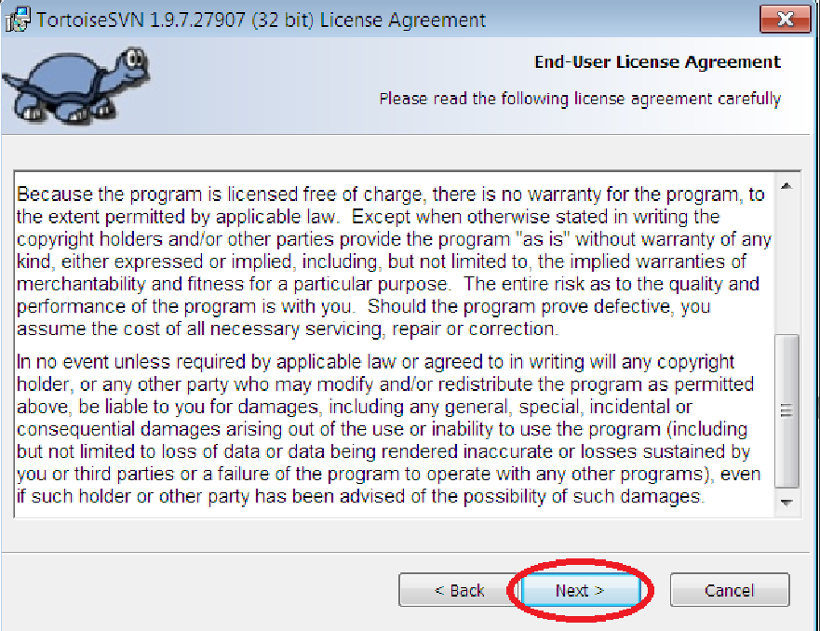

*Figure x. End-User License Agreement*

*Step 5*: After accepting the agreement, you need to configure the TortoiseSVN Custom Setup by disabling the *command line client tools* to *X (Entire Feature will be unavailable).*

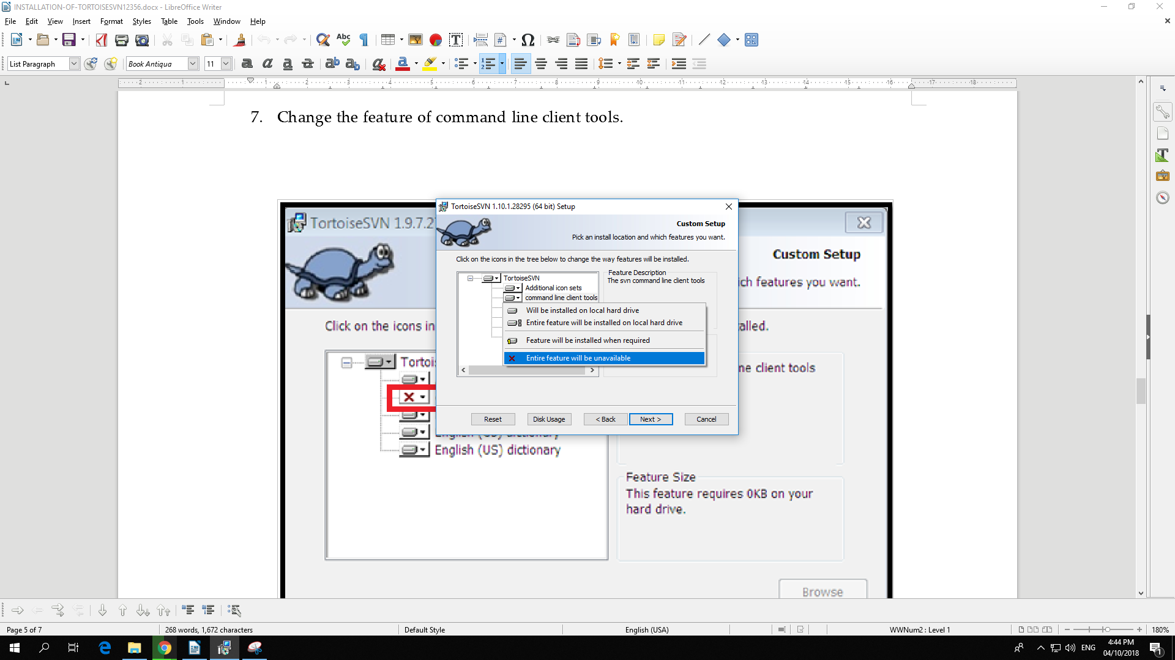

*Figure x. Disabling the command line client tools*

*Step 6*: After configuring the custom setup, just click on the **Install** button to begin the change installation.

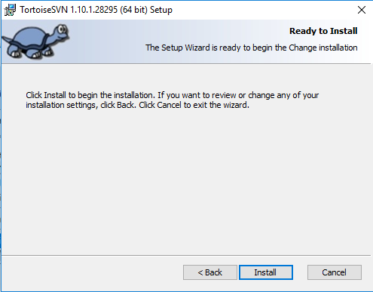

*Figure x. Ready to install*

*Step 7*: Now, you have successfully installed TortoiseSVN by clicking the **Finish** button.

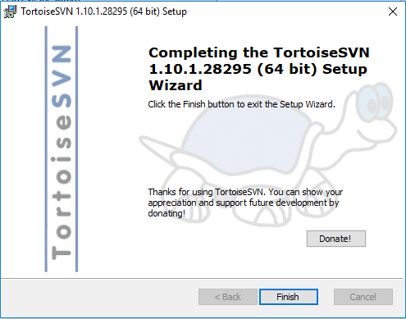

*Figure x. Completing the setup of TortoiseSVN*

*Step 8*: Proceed to your desktop, and then right click your mouse. You can now see that TortoiseSVN is already installed in your computer.

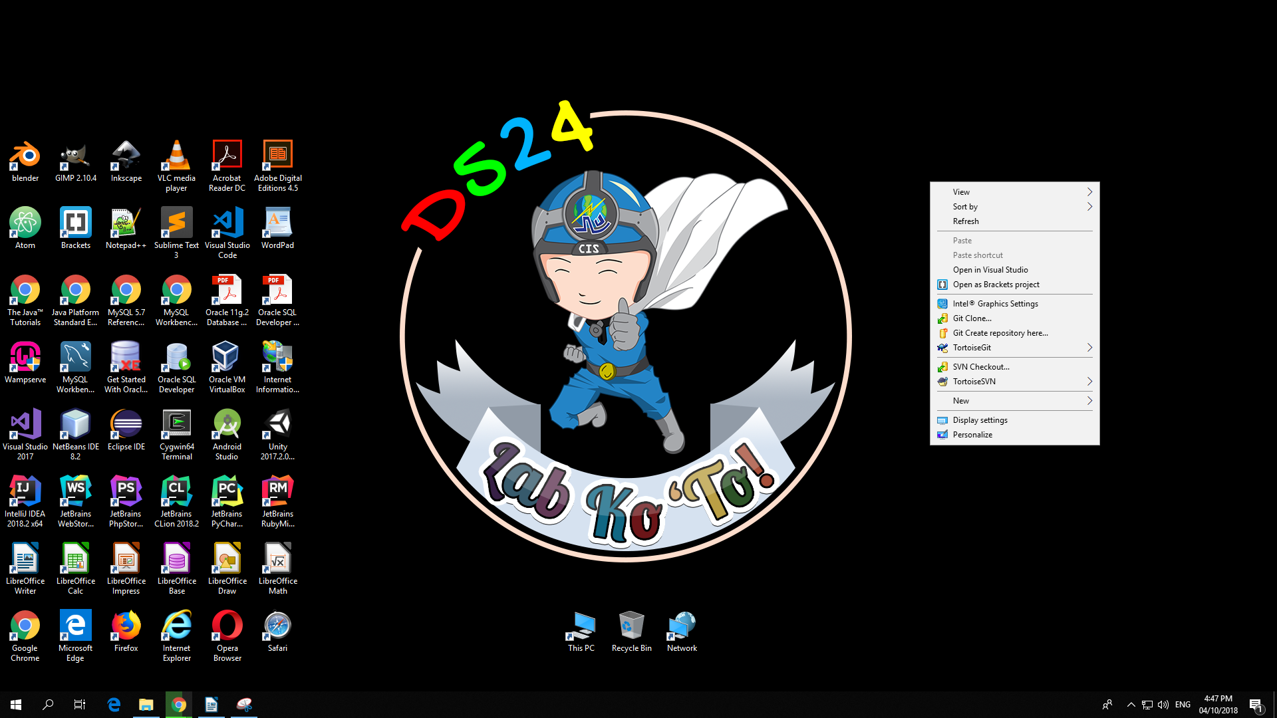

*Figure x. Successful installation of TortoiseSVN*

USER MANUAL (SVN)

Step 1: **sudo add-apt-repository multiverse**

Step 2: **sudo apt-get update**

Step 3: **sudo apt-get install apache2**

Step 4: **sudo apt-get install subversion libapache2-mod-svn libsvn-dev**

Step 5: **sudo a2enmod dav**

**sudo a2enmod dav_svn**

**sudo service apache2 restart**

Step 6: **cd /etc/apache2/mods-enabled/dav_svn.conf**

Alias /svn /var/lib/svn  
 <Location /svn>  
  
 DAV svn  
 SVNParentPath /var/lib/svn  
  
 AuthType Basic  
 AuthName "Subversion Repository"  
 AuthUserFile /etc/apache2/dav_svn.passwd  
 Require valid-user  
   
 </Location>

Step 7: **sudo mkdir -p /var/lib/svn/**

Step 8: **sudo svnadmin create /var/lib/svn/progAppsLab**

Step 9 : **sudo chown -R www-data:www-data /var/lib/svn**

Step 10: **sudo chmod -R 775 /var/lib/svn**

Step 11: **sudo htpasswd -cm /etc/apache2/dav_svn.passwd admin**

Username: admin

Password: admin

Step 12: **sudo htpasswd -m /etc/apache2/dav_svn.passwd user1**

Username: user1

Password: user1

**sudo htpasswd -m /etc/apache2/dav_svn.passwd user2**

Username: user2

Password: user2

*Step 1*: Install the subversion by typing the following command.

Command: sudo apt-get subversion

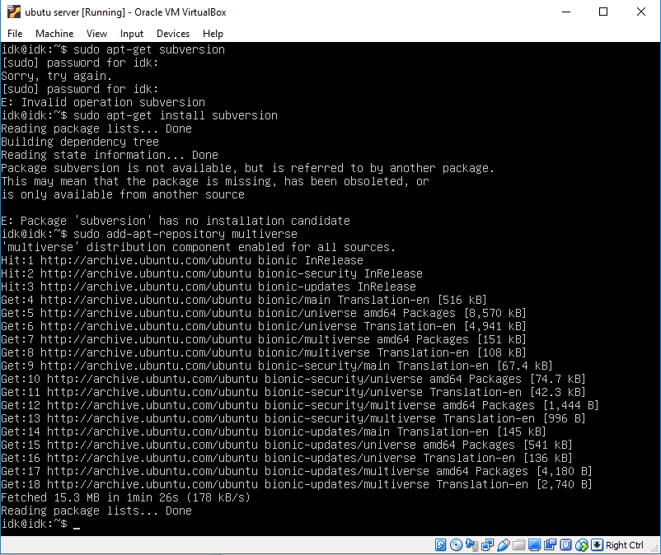

Step 2: By adding the SVN repository, you need to type the command below:  
Command: **sudo add- apt-repository**

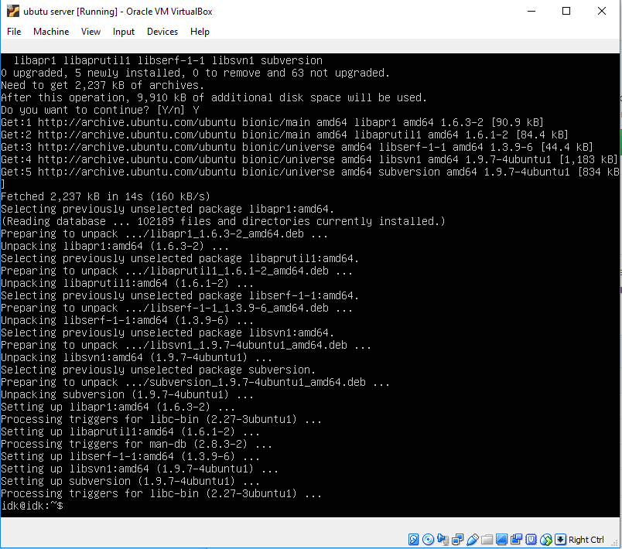

*Step 3:*  Install the apache2 by typing the command below.

Command: **sudo apt install apache2**

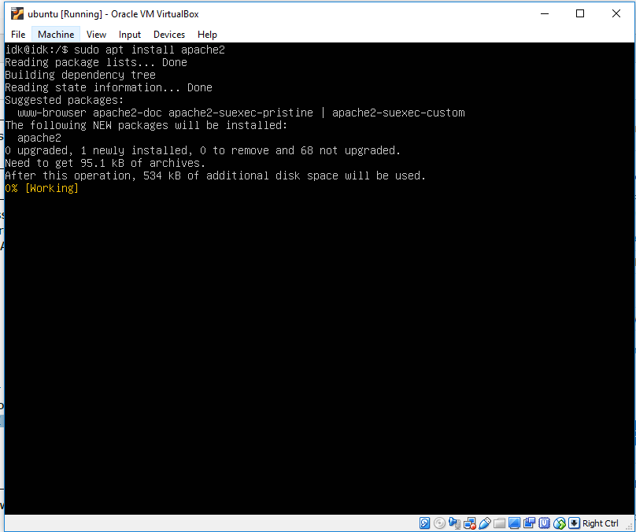

*Step 4*: Installing the dav-text

Command: sudo apt install dav-text

